[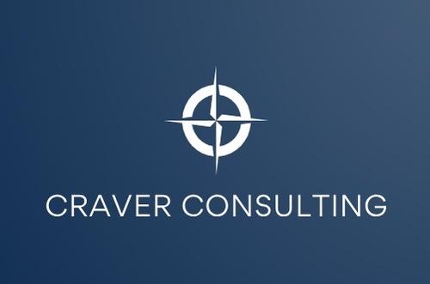](http://craverconsultingservices.com/)

|  |  |  |  |
| --- | --- | --- | --- |
| FIND HIDDEN VALUE FOR EXECUTIVES WHO TRANSITION OUTSIDE YOUR ORGANIZATION | |  | |
| **Compass Transition Coaching** creates value for both organizations and the leaders who exit | | | |
| **Proactively mitigate risk when off-boarding leaders due to performance or corporate restructure:** | | | |
| BRAND &  REPUTATION | OPERATIONAL  DISRUPTION | EMPLOYEE RELATIONS | FINANCIAL LIABILITIES |
| 1 | | | |
| How can organizations  generate value for  leaders after they leave?  2  With Three Points of the Compass…  3 | | Reflect  Look back and identify beneficial leadership lessons gained at the organization. | |
| Recharge  Look around and clarify where the leader truly wants to invest their time and energy. | |
| Rediscover  Look ahead and create the vision and plan for what their next professional endeavor will be. | |

Only Compass Transition Coaching delivers a holistic approach to guiding leader transitions   
out of organizations & preparing for what’s next.

* Facilitate a graceful transition for the executive & organization
* Provide personal outplacement offerings
* Help leaders re-energize their lives & careers
* Empower leaders to make the right choices for themselves

|  |
| --- |
| Ready to gain sustainable ROI from  Executive Outplacement Services?  Craver Consulting partners with clients to ensure a healthy and holistic  leadership experience, business continuity, and a reinforced alumni brand.  GET STARTED |

|  |  |  |  |  |
| --- | --- | --- | --- | --- |
| **COMPASS TRANSITION COACHING DELIVERS LONG-TERM VALUE FOR EXECUTIVES AND BUSINESS** | | | | |
|  | **BUSINESS**  **SITUATIONS** | **COMPASS**  **TRANSITIONS** | **TRADITIONAL OUTPLACEMENT** |  |
|  |  |  |  |  |
|  | Corporate acquisition results in impact to executive leaders | Reframe severance “for me” rather than “done to me” | Services offered focus on executive search |  |
|  | Executive performance negatively impacts business results | Facilitate a graceful exit and business continuity | No services to mitigate employee relations risk |  |
|  | Stalled leadership succession leads to redundancy | Help high potential leaders explore their options | No services to gain value from leaders who seek external opportunities |  |



|  |  |
| --- | --- |
|  | **CRAVER CONSULTING**  As a Head of Talent for 4 companies, I have designed & managed executive transition programs for hundreds of global leaders.  Personally, I have experienced 30+ transitions In, Up & Out of companies. Based on these experiences, I offer personalized, practical and impactful transition experiences for leaders. |

[www.craverconsultingservices.com](http://craverconsultingservices.com/)